**Reaction rates**

***1st Instruction to pupils… most pictures are links. HOLD control and click them to bring you to another dimension.***

***Cognitive objectives: (ie. what you need to know)***

1 Before a reaction can proceed (i.e. a fruitful one) three (3) criteria must be met

1. the particles must collide
2. the particles must have sufficient energy ≥ Ea (Activation Energy)
3. The particles must collide in the right place/spot i.e. they need to have the correct orientation

[](http://www.chemguide.co.uk/physical/basicrates/introduction.html)

2 Describe the effect of each of the following factors on the rates of chemical reactions:

a) nature of reactants

b) concentration of reactants

c) pressure (gases)

d) state of subdivision of reactants

e) temperature

f) catalyst

3 Describe the transition state (activated complex) in a reaction as the highest energy state for the reacting system which:

1. corresponds to some stage in the reaction at which bond-breaking and bond-formation is taking place
2. is unstable, having no more than a temporary existence, and explain its significance.
3. a stage during a reaction where it proceeds spontaneously.

4 Define the activation energy of a reaction and explain its significance to the reaction rate. This is the energy required to energise the reactants before a reaction can proceed. Reactions cannot proceed if the particles do not have energy ≥ Ea (Activation Energy)

5 The Law of Conservation of Energy states that in a system of constant mass, energy cannot be created nor destroyed, it is simply converted from one form to another.

6 The Law of Conservation of Mass is also called the 1st Law of Thermodynamics, what else is this called?

7 Draw and interpret potential energy diagrams for exothermic and endothermic processes showing the transition state (activated complex), activation energy and heat of reaction (ΔH)

**FIRST HAVE A PLAY WITH THIS… Instructions to follow**



**^^Please double click me for an interactive model of reaction systems^^**

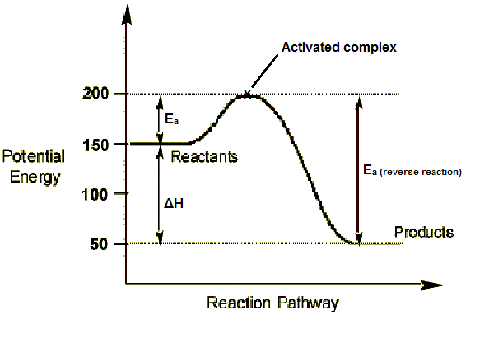

Exothermic reaction:

In the above diagram note that for the forward reaction the H (enthalpy) of the products is –ve (lower) relative to that of the reactants. The difference in H (enthalpy) is released as heat to the surroundings and the system gets hot. The energy required to break chemical bonds is less than the energy released when new bonds form.

Endothermic reaction:

In the above diagram note that for the reverse reaction the H (enthalpy) of the products (labelled reactants in the diagram) is +ve (higher) relative to that of the reactants (labelled products in the diagram). The difference in H (enthalpy) is absorbed as heat from the surroundings and the system gets cold. The energy required to break chemical bonds is greater than the energy released when new bonds form.

8 For every thermodynamic process and its reverse the ΔH’s are numerically equal but of opposite sign. This is a consequence of the Law of Conservation of Energy. In the diagram above the ΔH’s for the forward and reverse reactions are numerically equal.

[](http://www.chemguide.co.uk/physical/basicrates/energyprofiles.html#top)

9 Hess’ Law of Heat Summation is a consequence of the 1st Law of Thermodynamics, which states that regardless of the pathway by which a reaction proceeds, the sum of the ΔH’s in a multi-sequential process = the ΔH if the reaction were to proceed in a single step.

e.g. find the ΔH for the following reaction S + O2 **→** SO2

from the following data:

2S + 3O2 **→** 2SO3 ΔH = **−** 766kJ

2SO2 + O2 **→** 2SO3 ΔH = **−** 1657kJ

Reverse the second equation (don’t forget to change the sign on the ΔH from – 1657 kJ to + 1657 KJ) and add it to the first equation. Divide the answer by 2 to give the correct ΔH for the process

S + O2 **→** SO2; ΔH = (− 766 + − (− 1657)) ÷ 2 = + 445.5 KJ

10 Explain the Collision Theory of reaction rates identifying that as prerequisites for any successful reaction:

a) the reacting particles must have an appropriate collision orientation, and

b) the reacting particles must collide with sufficient energy.

11 Use the Collision Theory and a potential energy diagram or kinetic energy distribution curve, where appropriate, to explain the effect of the following factors on rates of chemical reactions:

[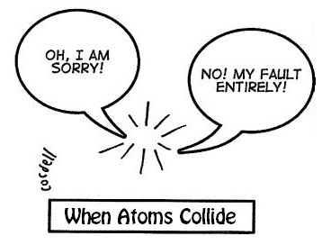](http://www.kscience.co.uk/animations/collision.htm)

a) **NATURE** of the reactants

Energy is required to break chemical bonds while energy is released when new bonds form. If no bonds need to be broken then the reaction can proceed instantaneously

e.g. precipitation reactions: ions are already formed Ag+(aq) + Cl-(aq) = AgCl((s).

On the other hand the burning of magnesium ribbon in air requires the magnesium to be heated to a high temperature and the chemical bonds in the oxygen molecule to be broken prior to the reaction proceeding:2 Mg(s) + O2(g) = 2MgO(s)

b) **CONCENTRATION** of reactants

Concentration is molL-1 for solutions. The more particles there are the greater the number of collisions. The greater the number of collisions the faster the rate of reaction.

[](http://www.chemguide.co.uk/physical/basicrates/concentration.html#top)

c) **PRESSURE** (In gases)

Pressure and concentration for gases are synonymous (n ≡ P). If the pressure is increased the volume is decreased and the concentration is increased. Consequently there are more particles per unit volume, therefore the number of collisions increase and so too does the rate of reaction. Conversely if the pressure is decreased, the volume increases and the concentration decrease. Consequently there are less particles per unit volume, therefore the number of collisions decreases and so too does the rate of reaction.

[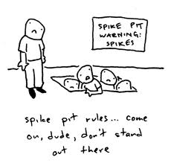](http://www.chemguide.co.uk/physical/basicrates/pressure.html#top)

Peer Pressure?! à

d) State of subdivision of reactants (**SURFACE AREA**)

Particles need to collide. If the surface area is increased (i.e. powder as opposed to lumps) there will be more surface (particle) for reacting particles to collide with. Consequently reaction rate will increase.

[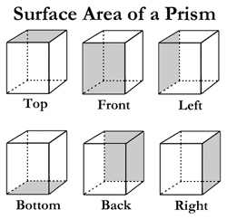](http://www.chemguide.co.uk/physical/basicrates/surfacearea.html#top)

e) **TEMPERATURE**

Temperature is the mean kinetic energy of the particles (Ek = ½mv2).

Ea

Number of particles

Kinetic energy (kJ mol-1)

T1

T2

[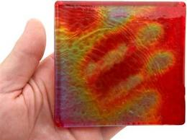](http://www.chemguide.co.uk/physical/basicrates/temperature.html#top)If the mean Ek o the particles increases (i.e. the temperature increases) it follows that the velocity of the particles also increases and so too does the number of collisions. In the graph above the temperature T1 < T2 and as the temperature increases more particles (area under the curve) will also have energy ≥ Ea. Consequently the rate of reaction also increases.

f) **CATALYSTS**.

Catalysts are substances that can alter the rate of a chemical reaction. They do this by affording an alternative energy pathway by which the reaction can proceed. They lower the Ea (Energy of Activation).

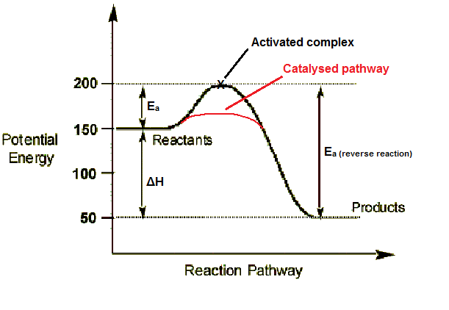

Catalysts may take an active part in the reaction or supply a surface on which reactants (gases) can react. They are not consumed in the reaction i.e. they are regenerated. Enzymes are biological catalysts that allow complex chemical reactions in biological systems to proceed at body temperature (370C) which would not ordinarily occur at such low temperatures. Most enzymes either add water as they facilitate the splitting of large molecules (hydrolases) or facilitate the building of large molecules by eliminating water in condensation reactions.

***Examples:***

|  |  |  |
| --- | --- | --- |
| **Process** | **Reaction** | **Catalyst** |
| Haber Process | 3H2(g) + N2(g) 2NH3(g) | Fe |
| Contact Process | 2SO2(g) + O2(g) 2SO3(g) | V2O5 |
| Esterification | Alcohol + Alkanoic acid Ester + Water | H+ (H2SO4) |
| Hydrogenation of Fats | Alkene + H2 = Alkane | Ni |
| Disproportioanation of H2O2 | 2H2O2 = O2 + 2H2O | MnO2 |

[](http://www.chemguide.co.uk/physical/basicrates/catalyst.html#top)

**At the end of this activity, you should be able to:**

– describe a chemical reaction at the atomic level as a collision of reactant molecules  
– discuss the factors that govern the effectiveness of collisions  
– explain the course of a reaction in terms of activation energy and an activated complex  
– use energy diagrams to show the course of a reaction  
– define a reaction mechanism  
– give examples of chemical reactions that do not require collisions between molecules to occur.

[](http://chem.salve.edu/chemistry/temp2a.asp)

<http://phet.colorado.edu/en/simulation/reactions-and-rates>

Please see the extra notes on how to use this program to demonstrate the factors affecting rate.



**CHECK YOUR UNDERSTANDING!**

1. The rate of a reaction depends upon: Choose an item
2. Which of the following statement(s) about a reaction mechanism is/are true?

|  |  |
| --- | --- |
| I. The mechanism is the series of steps needed to complete a reaction. | |
| II. The rate of a reaction is only as fast as the slowest step in the mechanism. | |
| III. You can usually deduce the reaction mechanism from its reactants and products.  Choose an item. | |
| ***Use your knowledge of collision theory and the energy distribution shown at right to answer questions 3 - 5. Assume that the graph shows the range of energies of collision of a collection of reactants at two temperatures.*** | http://ths.sps.lane.edu/chemweb/unit11/problems/rxnrate/Energy%20Distribution.jpg | |

1. Which is the highest temperature?

Choose an item.

1. Which of the curves has the greatest number of collisions possessing the activation energy?

Choose an item.

1. If a catalyst were used, how would the distributions change?

Choose an item.

Check your answers…



|  |  |
| --- | --- |
| ***Use your knowledge of collision theory and the potential energy diagram shown at right to answer questions 6 - 10. Assume the energy values are in Kilojoules.*** | http://ths.sps.lane.edu/chemweb/unit11/problems/rxnrate/Potential%20Energy%20Diagram%203.jpg |

1. Which letter shows the potential energy of the activated complex?

Choose an item.

1. What is the http://ths.sps.lane.edu/chemweb/unit11/problems/rxnrate/delta.gifH of the reaction?

Choose an item.

1. Which letter shows the activation energy?

Choose an item.

1. How would the graph change if the temperature were raised?

Choose an item.

1. How would the graph change if a catalyst were used.

Choose an item.

Check your answers…

